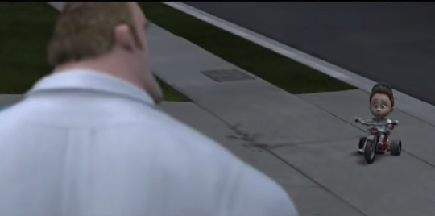 | “What are you waiting for?” -Mr. Incredible  “I dunno. Something amazing, I guess.” -boy on tricycle

The definition of precipice is a “hazardous situation.” It’s funny that “precipice” is the first and strongest word that comes to mind when I think about where I am in my personal and professional journey. At work, I’ve been stuck in contractor positions for the last five years, but I haven’t been able to convert to a fulltime employee. At home, I’m on the precipice of being considered a screenwriter, having finally finished the first draft of a story, two years in the making. I’m on the precipice of leveraging my life experience up to this point, to shape my next 40 years and Comm Lead is going to help.

My daughter Opal turns nine next week. Watching her build, hammer and get frustrated when she’s waiting to use my screwdriver is hilarious and rewarding. Opal informs my personal narrative daily, mostly because she’s my little shadow. With her studying my every move, I’m intentional in how she sees me utilize my time. Even while I teach her, she influences my decisions in how I prioritize the “important” things in life. Hearing her say, “mommy, play with me!” puts everything else on the back burner because I fear the day, she doesn’t want to spend time with mom anymore.

The struggle for attention is pandemic across work and play. In the office, those who need attention suck up time and energy. It’s another reason I guard my time so fiercely. As Bill Gates said in his Netflix biography recently, time is the only thing that’s finite. You can’t make more time. Grad school is a risk. My brother isn’t convinced a master’s degree will result in a salary increase. If he’s right, I might waste my time and money, but I wouldn’t be here if I thought he was right. I’m excited every day, now that I get to learn from like-minded communications experts and industry leaders in storytelling. Maybe I’ll get to film my screenplay, or maybe I’ll get laughed offstage, but I’d rather my kids see me fail while trying, than not try.

Creating time for myself to sleep in, catch up on work and plan even more opportunities for my kids is what life is about. I always knew I’d continue my education, it was just a matter of when and what program. For the last ten years, I’ve learned how to build chicken coops, garden and care for small farm animals. I broke back into the corporate world once the kids were in school and now it’s apparent, they pay attention to everything I do, I’m grateful they get to see me work through a graduate program.

Sometimes I look into the mirror and think “what are you waiting for?” And of course, I reply, “I don’t know. Something amazing I guess.” That’s what the Comms Lead program is; something amazing, that I’m planning to use to combine my program management experience with my love of writing, marketing and my outdoor hobbies. With kids, days are long, but years are short. I feel strongly that the time I spend in this program will enrich and embolden the time I spend with my family in the future. I’m increasingly unapologetic with how I spend my time. Investing in myself is vital, even if it threatens to lead me off a precipice for a while.

